* **Practice problem 3.1**

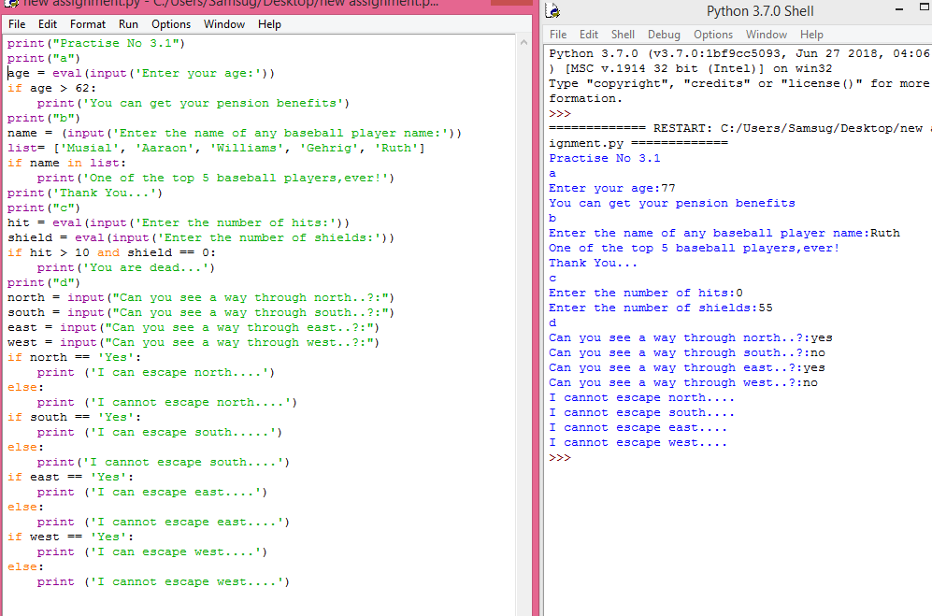

* **PRACTICE PROBLEM 3.3**

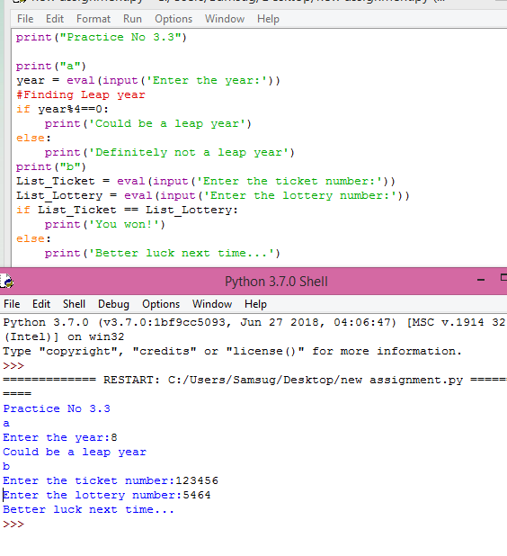

* **PRACTICE PROBLEM 3.4**

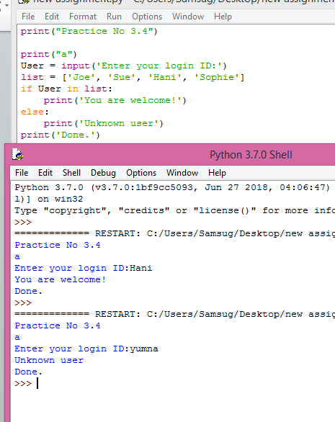

* **PRACTICE PROBLEM 3.5**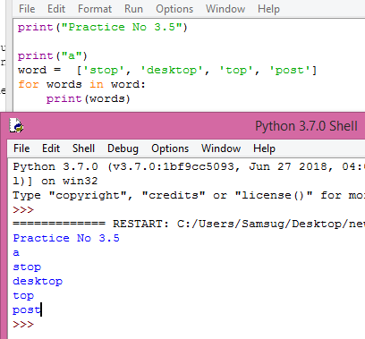

**PRACTICE PROBLEM 3.6**

* 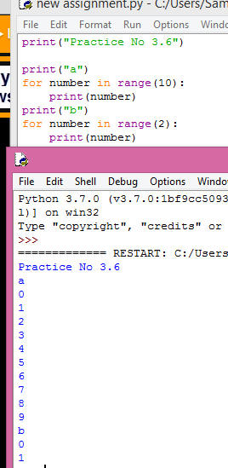
* **PRACTICE PROBLEM 3.7**

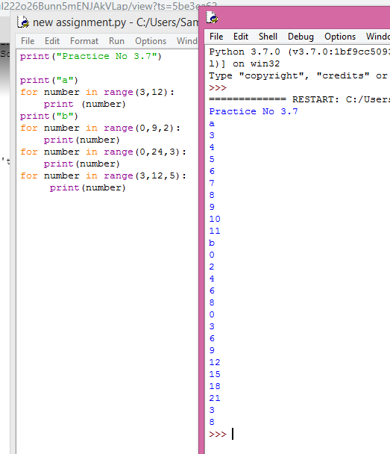

* **PRACTICE PROBLEM 3.8**

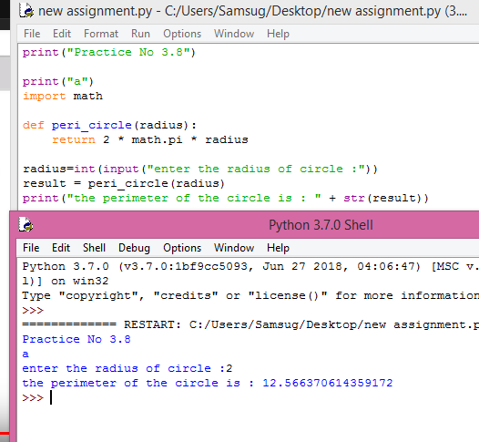

* **PRACTICE PROBLEM 3.9**

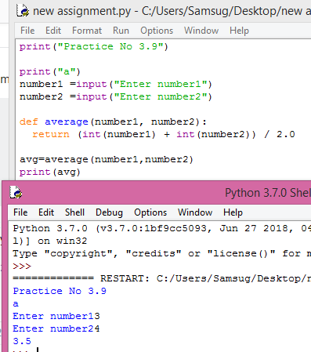

* **PRACTICE PROBLEM 3.10**

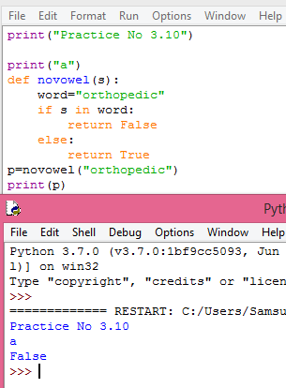

* **PRACTICE PROBLEM 3.11**

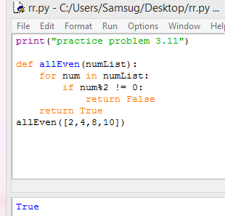

* **PRACTICE PROBLEM 3.12**

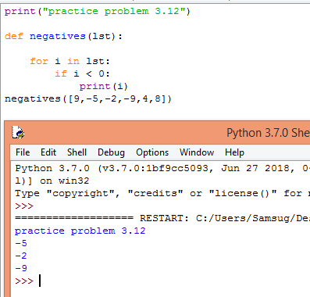

* **PRACTICE PROBLEM 3.13**

